Measurement Protocol PAX

General Information:

Test date: 11/8/22 | Date prev. test: NA | Test number: 1
Tested by: Sarah Schoultz | PAX number: PB-020 | Installed at ant.:
Comments:
Known problems: Detector on Y pam broken

Setup:

Power supply: | OK NOK | Communication: | OK NOK
Supply current +6V: 1.046mA |  | ssh obs@antcntl
Supply current -6V: 0.104mA |  | ssh ataant@ant0 | pw: q@n@t
Supply current +5V: 0.041mA |  | telnet pax | “help”
 |  | CTRL + ] | “close”

RF Test with VNA:

VNA Setup:

Load configuration: Passband_PAX.csa
Freq Start: 1.0 GHz | Freq Stop: 13.0 GHz | Power Level: -20 dBm
Averaging: enabled | Averaging count: 15 | N. Points: 801
VNA : Agilent N5230C 10MHz - 20GHz

VNA to PAX connection: | 1m ABC-CA18 Cable + 20dB Attenuator
Input Power Level to PAX:  (Measured) | @1GHz:  -40.2dBm | @4GHz:  -40.7dBm | @8GHz:  -41.2dBm | @12GHz:  -41.4dBm

PAX to VNA connection: | 2m Fibre Cable + Fibre Diode + AOX Amplifier + 1m ABC-CA18 Cable

Measured Passband with Attenuator set to 7dB each (Complete Link):

X
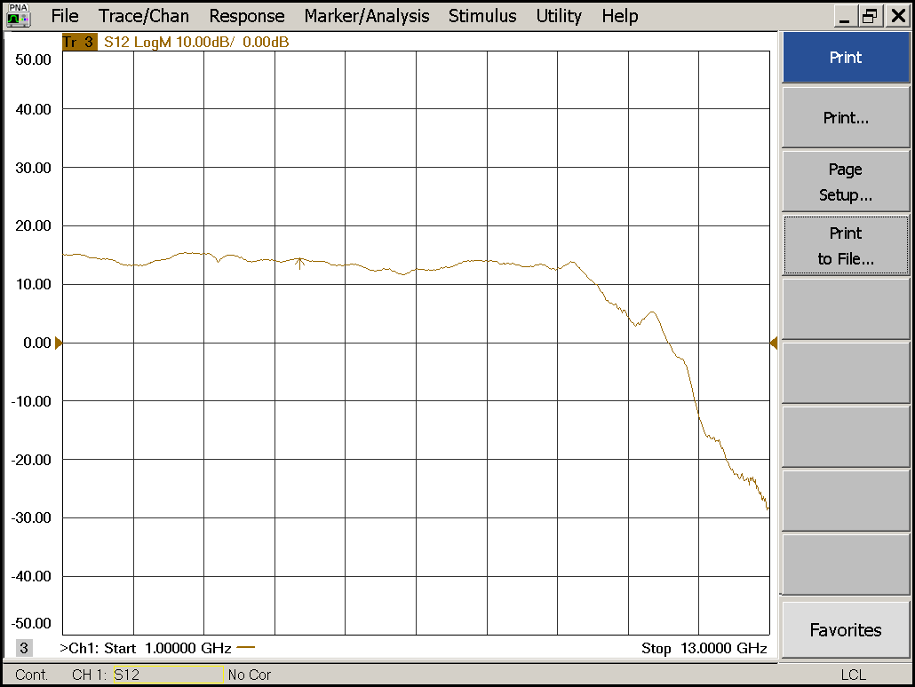

Flatness: | OK NOK | Unwanted Features: | Yes No

Y

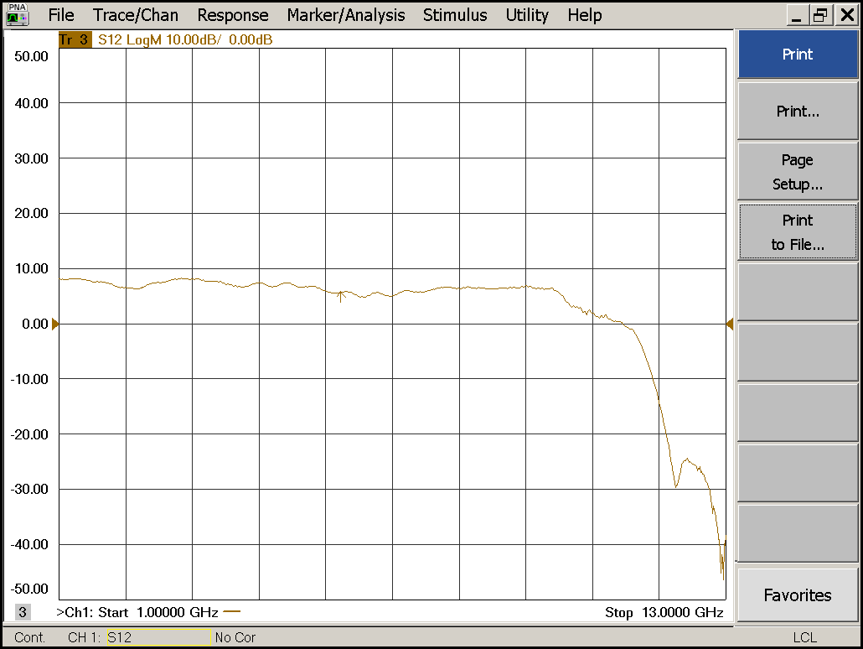

Flatness: | OK NOK | Unwanted Features: | Yes No

Power Sweep (Complete Link):

Load configuration: Power_Sweep_PAX.csa
Power Start: -40dBm | Power Stop: -20dBm | Frequency : 4.0GHz
PAM Attenuator: 0dB |  | N. Points: 801

X
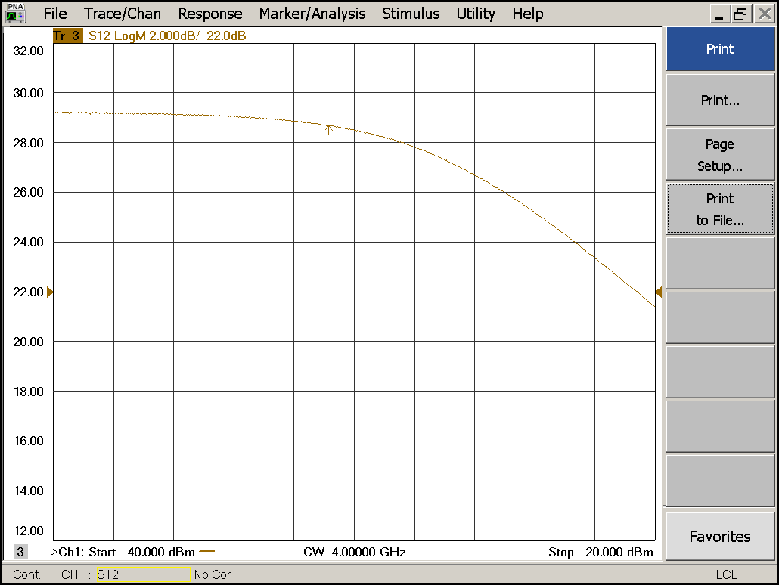

Compression point: | OK NOK | Unwanted Features: | Yes No

Y
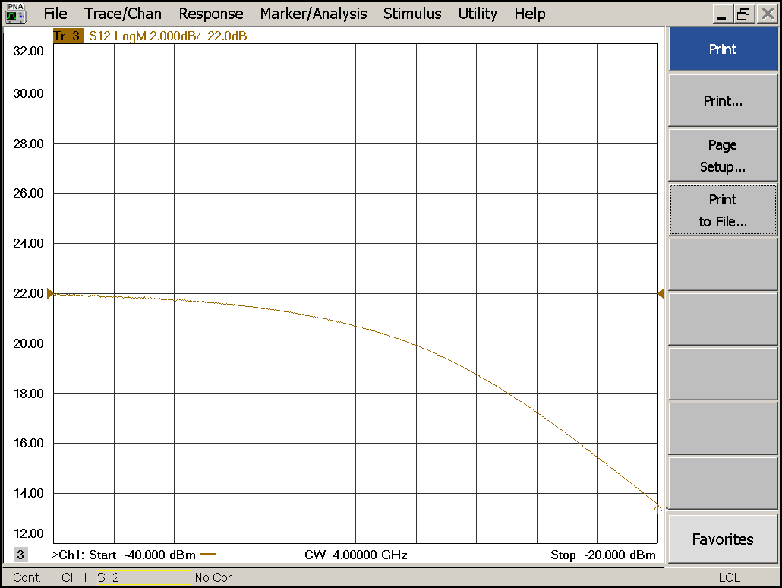

Compression point: | OK NOK | Unwanted Features: | Yes No

Detector Calibration and Attenuator Sweep Pol X:

Load configuration: Detector_Calibration_PAX.csa
Freq : 4.0 GHz | Power Level: -20dBm | Sweep Time: -20sec
Sweep Mode: CW | Power Level at PAX Input (Measured): -40.6dBm

X
CW Input Power [dBm]: | Attenuator Value A [dB]: | Attenuator Value: B [dB]: | Detector  Value: | Power Meter  Value [dBm]:
-40.6 | 0 | 0 | - | 14.0
-40.6 | 0 | 3 | - | 13.9
-40.6 | 0 | 6 | - | 12.6
-40.6 | 0 | 9 | 0.8496 | 10.0
-40.6 | 0 | 12 | 0.6362 | 7.1
-40.6 | 0 | 15 | 0.4039 | 4.4
-40.6 | 0 | 18 | 0.2180 | 1.1
-40.6 | 0 | 21 | 0.1178 | -2.1
-40.6 | 3 | 21 | 0.0585 | -5.4
-40.6 | 6 | 21 | 0.0305 | -8.4
-40.6 | 9 | 21 | 0.0163 | -11.4
-40.6 | 12 | 21 | 0.0089 | -14.4
-40.6 | 15 | 21 | 0.0053 | -17.3
-40.6 | 18 | 21 | 0.0033 | -20.6
-40.6 | 21 | 21 | 0.0024 | -23.7
-40.6 | 24 | 21 | 0.0020 | -26.5
-40.6 | 27 | 21 | 0.0018 | -29.5
-40.6 | 30 | 21 | 0.0016 | -32.7
-40.6 | 30 | 24 | 0.0016 | -35.4
-40.6 | 30 | 27 | 0.0016 | -37.8
-40.6 | 30 | 30 | 0.0016 | -40.2

Use Noise Source: Atlantic AS6333
Freq : 1.0 - 12.0GHz | Power Level: -41.8dBm
DC Supply: 28V

X
CW Input Power [dBm]: | Attenuator Value A [dB]: | Attenuator Value: B [dB]: | Detector  Value: | Power Meter  Value [dBm]:
-41.8 | 0 | 0 | - | 12.0
-41.8 | 0 | 3 | - | 10.9
-41.8 | 0 | 6 | - | 9.2
-41.8 | 0 | 9 | 0.8496 | 6.9
-41.8 | 0 | 12 | 0.7116 | 4.2
-41.8 | 0 | 15 | 0.4657 | 1.8
-41.8 | 0 | 18 | 0.2538 | -1.4
-41.8 | 0 | 21 | 0.1390 | -4.4
-41.8 | 3 | 21 | 0.0746 | -7.5
-41.8 | 6 | 21 | 0.0381 | -10.5
-41.8 | 9 | 21 | 0.0205 | -13.4
-41.8 | 12 | 21 | 0.0109 | -16.4
-41.8 | 15 | 21 | 0.0067 | -19.1
-41.8 | 18 | 21 | 0.0039 | -22.4
-41.8 | 21 | 21 | 0.0027 | -25.6
-41.8 | 24 | 21 | 0.0021 | -28.5
-41.8 | 27 | 21 | 0.0018 | -31.3
-41.8 | 30 | 21 | 0.0017 | -34.6
-41.8 | 30 | 24 | 0.0017 | -37.1
-41.8 | 30 | 27 | 0.0016 | -39.2
-41.8 | 30 | 30 | 0.0016 | -41.2

Detector Calibration and Attenuator Sweep Pol Y:

Load configuration: Detector_Calibration_PAX.csa
Freq : 4.0 GHz | Power Level: -20dBm | Sweep Time: -20sec
Sweep Mode: CW | Power Level at PAX Input (Measured): -40.6dBm

Y
CW Input Power [dBm]: | Attenuator Value A [dB]: | Attenuator Value: B [dB]: | Detector  Value: | Power Meter  Value [dBm]:
-40.6 | 0 | 0 | - | 13.3
-40.6 | 0 | 3 | - | 12.9
-40.6 | 0 | 6 | - | 11.8
-40.6 | 0 | 9 | 0.0011 | 9.4
-40.6 | 0 | 12 | 0.0010 | 6.5
-40.6 | 0 | 15 | 0.0010 | 3.7
-40.6 | 0 | 18 | 0.0010 | 0.4
-40.6 | 0 | 21 | 0.0010 | -2.5
-40.6 | 3 | 21 | 0.0010 | -5.9
-40.6 | 6 | 21 | 0.0010 | -8.8
-40.6 | 9 | 21 | 0.0010 | -11.8
-40.6 | 12 | 21 | 0.0010 | -14.7
-40.6 | 15 | 21 | 0.0010 | -17.6
-40.6 | 18 | 21 | 0.0010 | -20.8
-40.6 | 21 | 21 | 0.0010 | -23.9
-40.6 | 24 | 21 | 0.0010 | -26.6
-40.6 | 27 | 21 | 0.0010 | -29.6
-40.6 | 30 | 21 | 0.0010 | -32.7
-40.6 | 30 | 24 | 0.0010 | -35.3
-40.6 | 30 | 27 | 0.0010 | -37.8
-40.6 | 30 | 30 | 0.0010 | -40.0

Use Noise Source: Atlantic AS6333
Freq : 1.0 - 12.0GHz | Power Level: -41.8dBm
DC Supply: 28V

Y
CW Input Power [dBm]: | Attenuator Value A [dB]: | Attenuator Value: B [dB]: | Detector  Value: | Power Meter  Value [dBm]:
-41.8 | 0 | 0 | - | 12.08
-41.8 | 0 | 3 | - | 10.9
-41.8 | 0 | 6 | 0.0011 | 9.15
-41.8 | 0 | 9 | 0.0010 | 7.0
-41.8 | 0 | 12 | 0.0010 | 4.3
-41.8 | 0 | 15 | 0.0010 | 1.8
-41.8 | 0 | 18 | 0.0010 | -1.4
-41.8 | 0 | 21 | 0.0010 | -4.2
-41.8 | 3 | 21 | 0.0010 | -7.3
-41.8 | 6 | 21 | 0.0010 | -10.3
-41.8 | 9 | 21 | 0.0010 | -13.1
-41.8 | 12 | 21 | 0.0010 | -16.0
-41.8 | 15 | 21 | 0.0010 | -18.8
-41.8 | 18 | 21 | 0.0010 | -22.0
-41.8 | 21 | 21 | 0.0010 | -25.0
-41.8 | 24 | 21 | 0.0010 | -27.9
-41.8 | 27 | 21 | 0.0010 | -30.7
-41.8 | 30 | 21 | 0.0010 | -33.8
-41.8 | 30 | 24 | 0.0010 | -36.4
-41.8 | 30 | 27 | 0.0010 | -38.5
-41.8 | 30 | 30 | 0.0010 | -40.6

Inspection:

Visual:
Fibre Connectors Clean | Comments: | OK NOK
Fibre Connector Mechanical | Comments: | OK NOK
RF Cable | Comments: | OK NOK
RF Connectors Clean | Comments: | OK NOK
RF Connector on PAM screws tight | Comments: | OK NOK

Functions:
Read Temperature Value | Comments: 29.5 | OK NOK
LNA Settings | Comments: | OK NOK
Temperature Stabilisation | Comments: | OK NOK

